Optimal Configuration of Distributed Integrated Energy System Considering Source-Load Matching with Energy Quality Difference

1st Haonan Zheng
College of Energy Engineering
Zhejiang University
Hangzhou, China
haonan.zheng@zju.edu.cn
4th Xueru Lin
College of Energy Engineering
Zhejiang University
Hangzhou, China
linxueru@zju.edu.cn
2nd Xiaojie Lin
College of Energy Engineering
Zhejiang University
Hangzhou, China
xiaojie.lin@zju.edu.cn
5th Xu Zhang
dept. name of organization
(of Affiliation)
State Grid Zhejiang Intergrated Energy Service Company
Hangzhou, China
876101205@qq.com
3rd Wei Zhong
College of Energy Engineering
Zhejiang University
Hangzhou, China
zhongw@zju.edu.cn
line 1: 6th Given Name Surname
line 2: dept. name of organization
(of Affiliation)
line 3: name of organization
(of Affiliation)
line 4: City, Country
line 5: email address or ORCID

Abstract—The escalating integration of renewable energy sources into integrated energy systems (IES) creates challenges in simultaneously achieving thermodynamic efficiency and economic viability. This work proposes a thermodynamically rigorous matching indicator that extends beyond traditional complementarity assessment by introducing an entropy-weighted energy quality coefficient framework. Unlike conventional source-load matching metrics that treat electricity, heat, and cooling as equivalent energy forms, this approach hierarchically weights different energy carriers based on the second law of thermodynamics—specifically incorporating exergy (availability) concepts with entropic corrections. The proposed metric combines weighted Euclidean distance with time-variant price signals to establish a novel bi-objective optimization framework: (1) minimizing mismatches in exergy-stratified energy flows, and (2) reducing operational costs. A case study of a German regional IES with 8 conversion devices demonstrates that the entropy-corrected energy quality weighting achieves 12.7% improvement in exergy efficiency while maintaining economic competitiveness (cost increase ≤3%). Comparative analysis with four alternative metrics (standard deviation-based, correlation coefficient-based, overlap degree-based, and unweighted Euclidean) validates the physical significance of the proposed approach. The work bridges thermodynamic fundamentals with practical system optimization, offering a new perspective for rational device configuration in renewable-dominant energy systems.

Current capacity planning strategies for Integrated Energy Systems (IES) typically evaluate source-load matching based solely on the quantitative balance of energy supply and demand. This approach neglects the fundamental difference in energy quality (exergy) among electricity, heat, and cold, leading to inefficient system configurations. To address this, this paper proposes a novel source-load matching quantification method based on energy quality coefficient-weighted Euclidean distance. First, based on the Second Law of Thermodynamics, Carnot factors are introduced to define the energy quality coefficients for heat and cold relative to electricity, establishing a unified evaluation benchmark. Second, a coupled matching index is constructed using Euclidean distance to penalize simultaneous multi-energy imbalances. This index is integrated into a bi-level planning model alongside economic objective. A case study based on a regional IES in Germany demonstrates that, compared to traditional fluctuation-based methods, the proposed approach effectively guides the system toward energy cascade utilization. It significantly improves exergy efficiency and reduces high-quality energy waste while maintaining economic viability.
Keywords—integrated energy system, capacity planning, exergy analysis, source-load matching

Introduction
District heating systems are critical infrastructure for urban energy supply, playing a vital role in global decarbonization efforts [1]. As heating systems transition towards smart thermal grids [2], the ability to accurately predict heat load demand becomes a prerequisite for operational optimization, peak shaving, and demand-side management [3]. Precise forecasting enables operators to adjust heat supply preemptively [4], thereby minimizing energy waste caused by overheating and ensuring thermal comfort.
Existing forecasting approaches fall into two primary categories [5]: physical modeling, termed white-box models, and data-driven modeling, known as black-box models. Physical models rely on detailed thermodynamic equations and building parameters, such as those used in TRNSYS [6] or EnergyPlus simulation engines [7]. While these methods offer high interpretability, they are often computationally expensive and difficult to scale due to the scarcity of precise geometric and material data [8]. Conversely, data-driven approaches, particularly deep learning models like recurrent neural networks and long short-term memory networks (LSTM) [9], have gained prominence for their ability to capture complex non-linear dependencies in historical data without requiring detailed physical parameters.
However, purely data-driven models face intrinsic limitations. They are fundamentally agnostic to physical laws, relying solely on statistical correlations. This often leads to poor generalization when the system encounters unseen weather conditions or operational shifts [10]. Deep learning models frequently exhibit a hysteresis effect, during rapid weather transitions such as large diurnal temperature swings. Because these models rely heavily on historical autoregressive patterns [11], they tend to react slowly to sudden changes in outdoor temperature, resulting in significant prediction errors and potential energy waste. In buildings with high volatility, the signal-to-noise ratio is low, making it difficult for deep learning models to distinguish between stochastic disturbances and actual load trends [12].
To bridge the gap between physical consistency and data-driven flexibility, Physics-informed machine learning has emerged as a promising paradigm [13]. In this context, we propose ThermoNet, a hybrid framework that augments an LSTM architecture with thermodynamic knowledge. Unlike complex simulations, ThermoNet utilizes a simplified envelope load feature as a deterministic prior, guiding the neural network to adhere to thermodynamic laws while learning residual behavioral patterns.
The main contributions of this study are as follows:
1) A physics-enhanced forecasting framework is proposed, which integrates a theoretical envelope load mechanism into the deep learning pipeline to instill physical intuition into the black-box model.
2) Based on operational datasets from two distinct building archetypes, the proposed model is rigorously evaluated, demonstrating superior robustness against volatility and effectively eliminating prediction latency during large temperature fluctuations.

Methodology

Energy Quality-Weighted Net Load Complementarity Index

Theoretical Foundation
The first law of thermodynamics alone provides insufficient guidance for system design, as it only addresses energy conservation without considering the quality (capacity for useful work) of different energy forms. The second law of thermodynamics, expressed through the exergy concept, quantifies this essential distinction.

**Definition of Exergy**: Exergy is the maximum theoretical useful work obtainable as a system equilibrates with a reference environment. For a flowing stream:

\[
Ex = E - E_{ref} - T_0(S - S_{ref})
\]

where E is energy, S is entropy, and the subscript "ref" denotes reference state conditions.

For steady-flow devices in energy systems, the exergy content can be related to physical properties through the exergy factor:

\[
\phi_i = \frac{Ex_i}{E_i}
\]

#### 2) Energy Quality Coefficients for Different Carriers

For an integrated energy system with three primary energy flows (electricity, heat, cooling), the energy quality weighting coefficients are:

**For Electricity**:
\[
\lambda_e = 1.0
\]

Electricity is pure exergy—all electrical work can theoretically be converted to other useful forms, and no exergy is lost in the thermodynamic sense when electricity flows through an ideal conductor.

**For Heat at Temperature Tₕ**:
\[
\lambda_h = 1 - \frac{T_0}{T_h} = \eta_{Carnot}
\]

where T₀ is the ambient/reference temperature (typically 298.15 K for standard conditions), and Tₕ is the supply temperature of the heating system. This factor represents the maximum thermodynamic efficiency achievable in converting thermal energy to useful work via a Carnot cycle. For typical district heating systems with Tₕ = 343.15 K (70°C), this yields:

\[
\lambda_h = 1 - \frac{298.15}{343.15} \approx 0.131
\]

**For Cooling at Temperature Tₓ**:
\[
\lambda_c = \frac{T_0 - T_c}{T_c}
\]

This expression emerges from the inverse Carnot relation for refrigeration cycles. For typical building cooling systems with Tₓ = 280.15 K (7°C):

\[
\lambda_c = \frac{298.15 - 280.15}{280.15} \approx 0.064
\]

**Physical Interpretation**: These coefficients indicate that:

- A 1 kWh thermal mismatch at typical heating temperatures requires approximately 13% of the exergetic correction compared to 1 kWh of electrical mismatch
- A 1 kWh cooling mismatch requires approximately 6.4% of the exergetic correction
- Therefore, management of electrical imbalances should take priority in system design, with thermal and cooling mismatches having substantially lower thermodynamic consequence

#### 3) Modified Net Load Definition

The net load for each energy carrier is defined as the difference between regional demand and system supply:

\[
NL_i(t) = D_i(t) - \sum_{j \in E_q} P_j(t)
\]

where:

- NL_i(t) = net load of energy carrier i at time t (kW)
- D_i(t) = demand for energy carrier i at time t (kW)
- P_j(t) = output power of device j at time t (kW)
- E_q = set of all supply devices
- i ∈ {electricity, heat, cooling}

#### 4) Energy Quality-Weighted Complementarity Index

Building upon the work of Zhang et al. [11], who established that net load standard deviation provides superior complementarity assessment compared to direct correlation analysis, we extend their methodology by incorporating energy quality weighting:

\[
CON_L^{weighted} = \sum_{i \in E_n} \lambda_i \cdot std(NL_i)
\]

where:

- CON_L^{weighted} = energy quality-weighted complementarity index (kW)
- λᵢ = energy quality coefficient for energy carrier i
- std(NL_i) = standard deviation of the net load time series for carrier i
- E_n = set of energy carrier types (electricity, heat, cooling)

The standard deviation is calculated as:

\[
std(NL_i) = \sqrt{\sum_{t=1}^{T} \frac{(NL_i(t) - \overline{NL_i})^2}{T-1}}
\]

where:

- NL_i(t) = net load value at time t (kW)
- $\overline{NL_i}$ = mean value of net load time series (kW)
- T = total number of time steps

**Advantages of the Proposed Metric**:

Compared to unweighted complementarity assessment, the energy quality-weighted approach provides:

1. **Thermodynamic Grounding**: Rather than treating all energy carriers equivalently, weights are derived from first principles (Carnot efficiency)
2. **Economic Alignment**: The weighting naturally reflects the fact that electrical imbalances are more difficult and expensive to manage than thermal imbalances
3. **Physical Meaningfulness**: Results guide equipment selection toward configurations that respect both thermodynamic reality and economic constraints
4. **Scalability**: The framework naturally extends to additional energy carriers (hydrogen, compressed air, etc.) simply by calculating their appropriate exergy coefficients

### B. Economic Evaluation Framework

The economic objective function remains consistent with standard practice in IES planning, considering three cost components:

\[
TC = IC + OC + MC
\]

where:

- TC = total annual cost (€/year)
- IC = annual investment cost (€/year)
- OC = annual operation cost (€/year)
- MC = annual maintenance cost (€/year)

**Annual Investment Cost**:

\[
IC = \sum_{i \in E_q} Co_i \cdot Pe_i \cdot \frac{IR(1+IR)^{l_i}}{(1+IR)^{l_i}-1}
\]

where:

- Co_i = specific investment cost of device i (€/kW)
- Pe_i = rated power of device i (kW)
- IR = investment discount rate (%)
- l_i = service life of device i (years)

**Annual Maintenance Cost**:

\[
MC = \sum_{i \in E_q} \zeta_i \cdot Co_i \cdot Pe_i \cdot \frac{IR(1+IR)^{l_i}}{(1+IR)^{l_i}-1}
\]

where ζᵢ is the maintenance coefficient for device i as a fraction of initial investment cost.

**Annual Operation Cost**:

\[
OC = \sum_{i \in E_n} \sum_{t=1}^{T} Co_i^{buy}(t) \cdot P_i^{buy}(t) \cdot \Delta t - \sum_{i \in E_n} \sum_{t=1}^{T} Co_i^{sell}(t) \cdot P_i^{sell}(t) \cdot \Delta t + Co_{cap} \cdot \max(P_{electricity}^{buy}(t))
\]

where:

- Co_i^{buy}(t), P_i^{buy}(t) = price (€/kWh) and power (kW) of energy flow i purchased at time t
- Co_i^{sell}(t), P_i^{sell}(t) = price (€/kWh) and power (kW) of energy flow i sold at time t
- Co_{cap} = capacity charge for electricity (€/kW·year)
- Δt = time step (hours)

This formulation accurately captures the real-world cost structure facing energy system operators, including time-varying commodity prices and peak demand charges.

### C. Two-Stage Optimization Framework

The overall optimization problem is solved using a two-stage planning approach that separates the planning (capacity allocation) phase from the operational (scheduling) phase. This decomposition provides computational tractability while ensuring physical consistency.

**Upper Model (Planning Stage)**:

- **Decision Variables**: Capacities of candidate devices
- **Objectives**:
- Minimize energy quality-weighted complementarity: CON_L^{weighted}
- Minimize total annual cost: TC
- **Constraints**: Energy balance, renewable energy minimum share, technical limits
- **Algorithm**: NSGA-II to generate Pareto-optimal solutions
- **Output**: Set of capacity allocation schemes with varying trade-offs between complementarity and economy

**Lower Model (Operation Stage)**:

- **Input**: Capacity allocations from upper model
- **Optimization**: Dispatch and storage scheduling to minimize operating costs
- **Method**: Deterministic optimization (linear programming)
- **Output**: Operation schedules and actual operational costs and complementarity values for each capacity allocation scheme

**Algorithm Steps**:

1. **Initialization**: Set boundary conditions and initial parameters including:
- Device technical and economic characteristics
- Hourly load profiles (electricity, heat, cooling)
- Meteorological data (ambient temperature, solar radiation, wind speed)
- Energy commodity prices
- Renewable energy share requirement

2. **Upper Model Execution**: Run NSGA-II multi-objective optimization to generate multiple planning schemes:
- Each population member represents a distinct capacity allocation
- Fitness evaluation based on economic objective
- Application of constraints (energy balance, renewable share)
- Output: Population of diverse planning schemes

3. **Lower Model Execution**: For each planning scheme from step 2:
- Input device capacities as fixed parameters
- Optimize hourly operation schedule over typical days
- Calculate actual operational costs and complementarity indicators
- Return results to upper model

4. **Iterative Refinement**:
- Update economic objective values in planning schemes with actual operational costs
- Update complementarity values with actual device dispatch results
- Check convergence (typically 100 generations)
- If not converged: return to step 2; if converged: proceed to results analysis

5. **Pareto Front Extraction**: From final population, identify all non-dominated solutions (Pareto-optimal) representing the efficient frontier of the complementarity-economy trade-off

---

##

The overall framework of the proposed method is illustrated in Fig. 1. It systematically integrates thermodynamic feature construction with a deep sequence learning architecture.
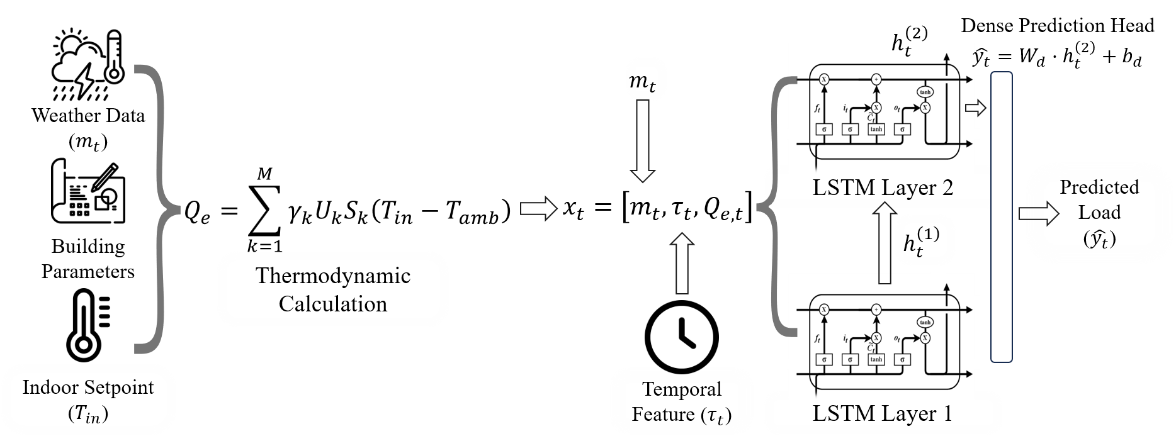
- Schematic diagram of the ThermoNet framework

Thermodynamic Feature Construction
To endow the neural network with interpretable domain knowledge, a thermodynamic prior feature is constructed based on the first law of thermodynamics. Recognizing that detailed dynamic parameters are often inaccessible, the theoretical envelope load ($Q_{e}$) is formulated based on simplified steady-state heat transfer principles:
$$\begin{aligned}Q_{e}=\sum_{k=1}^{M}{γ_{k}U_{k}S_{k}\left(T_{in}-T_{amb}\right)}\#\left(1\right)\end{aligned}$$
Where, $M$ represents the total number of heat transfer sub-regions (e.g., exterior walls, glazing, roof); $U_{k}$ denotes the heat transfer coefficient of component $k$, W/(m²·K); $S_{k}$ denotes the surface area of component $k$, m². $T_{in}$ and $T_{amb}$ are the indoor design temperature setpoint and the outdoor ambient temperature, K; $γ_{k}$ is the correction coefficient accounting for orientation effects.

ThermoNet Architecture
ThermoNet employs an LSTM [14] network as the backbone to capture temporal dependencies. The architecture is designed to fuse the mechanism-based prior ($Q_{e}$) with data-driven observations.

Thermodynamics-Enhanced Input
At time step $t$, the input vector $x_{t}$ is a hybrid concatenation of weather data, temporal data, and the calculated physical feature:
$$\begin{aligned}\begin{aligned}x_{t}=\left[m_{t},τ_{t},Q_{e,t}\right]\#(2)\end{aligned}\#\end{aligned}$$
Where $m_{t}$ includes outdoor temperature, humidity, and solar irradiance; $τ_{t}$ denotes sine-cosine encoded time variables; and $Q_{e,t}$ is the calculated envelope load.
To explicitly distinguish the proposed framework from the data-driven baseline, the input vector for the baseline LSTM is defined as $x_{t}^{base}=\left[W_{t},τ_{t}\right]$, this baseline setup serves to rigorously quantify the performance gain attributed specifically to the mechanism augmentation.

LSTM cell mechanism
The LSTM architecture processes the input sequence through a specific gating mechanism designed to regulate information flow. As illustrated in Fig. 2, each LSTM cell comprises a forget gate, an input gate, and an output gate. The forget gate determines the retention of prior state information, the input gate governs the assimilation of new data, and the output gate controls the emission of the current hidden state. The forward propagation dynamics are governed by the following equations:
$$\begin{aligned}f_{t}=σ\left(W_{f}⋅\left[h_{t-1},x_{t}\right]+b_{f}\right)\#\left(3\right)\end{aligned}$$
$$\begin{aligned}i_{t}=σ\left(W_{i}⋅\left[h_{t-1},x_{t}\right]+b_{i}\right)\#\left(4\right)\end{aligned}$$
$$\begin{aligned}o_{t}=σ\left(W_{o}⋅\left[h_{t-1},x_{t}\right]+b_{o}\right)\#\left(5\right)\end{aligned}$$
$$\begin{aligned}\tilde{C_{t}}=\tanh\left(W_{C}⋅\left[h_{t-1},x_{t}\right]+b_{C}\right)\#\left(6\right)\end{aligned}$$
$$\begin{aligned}C_{t}=f_{t}⊙C_{t-1}+i_{t}⊙\tilde{C_{t}}\#\left(7\right)\end{aligned}$$
$$\begin{aligned}h_{t}=o_{t}⊙\tanh\left(C_{t}\right)\#\left(8\right)\end{aligned}$$
Where, $f_{t}$, $i_{t}$, $o_{t}$ are forget gate, input gate, and output gate vectors, respectively; $W_{f}$, $W_{i}$, $W_{o}$, $W_{c}$ represent the weight matrices for the respective gates and cell state; $b_{f}$, $b_{i}$, $b_{o}$, $b_{c}$ denote the bias terms; $⊙$ denotes the element-wise product; $C_{t}$ and $h_{t}$ represent the cell state and the hidden state at time step $t$, respectively; $σ$ is the sigmoid activation function and $tanh$ refers to the hyperbolic tangent activation function.
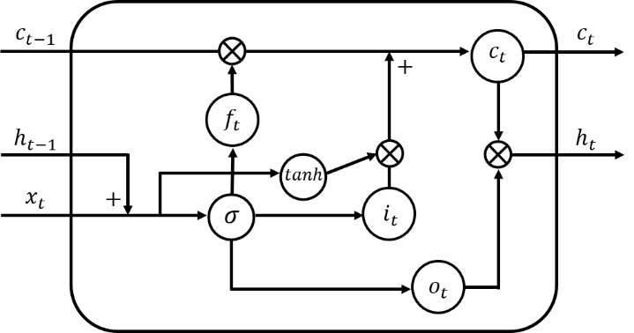
- Detailed schematic of an LSTM cell

Prediction Head
To capture deeper hierarchical temporal dependencies, ThermoNet employs a deep LSTM architecture consisting of two layers. Let $h_{t}^{\left(l\right)}$ denote the hidden state of the $l$-th layer at time step $t$. The sequence of hidden states output by the first layer, $h_{t}^{\left(1\right)}$, serves as the input to the second layer. Consequently, the hidden state of the second layer, denoted as $h_{t}^{\left(2\right)}$, encapsulates the high-level semantic features of the sequence. Finally, this vector is passed through a dense layer to generate the heating load prediction $\hat{y_{t}}$:
$$\begin{aligned}\hat{y_{t}}=W_{d}⋅h_{t}^{\left(2\right)}+b_{d}\#\left(9\right)\end{aligned}$$
Where, $\hat{y_{t}}$ represents the predicted heating load value; $h_{t}^{\left(2\right)}$ is the hidden state output from the second LSTM layer at time $t$; $W_{d}$ and $b_{d}$ denote the weight matrix and bias term of the dense layer, performing a linear transformation from the high-dimensional hidden space to the output space.

Evaluation Metrics
To rigorously quantify the forecasting performance of ThermoNet against baseline models, we employ three standard statistical metrics: MAE, RMSE and R². MAE and RMSE measure the average magnitude of prediction deviations, where lower values indicate superior accuracy. Conversely, R² assesses the goodness of fit, with a value closer to 1 indicating that the model better explains the variance in the observed data. The mathematical definitions are as follows:
$$\begin{aligned}\text{MAE}=\frac{1}{N}\sum_{t=1}^{N}{\left|y_{t}-\hat{y_{t}}\right|}\#\left(10\right)\end{aligned}$$
$$\begin{aligned}\text{RMSE}=\sqrt{\frac{1}{N}\sum_{t=1}^{N}{{\left(y_{t}-\hat{y_{t}}\right)}^{2}}}\#\left(11\right)\end{aligned}$$
$$\begin{aligned}R^{2}=1-\frac{\sum_{t=1}^{N}{{\left(y_{t}-\hat{y_{t}}\right)}^{2}}}{\sum_{t=1}^{N}{{\left(y_{t}-\overline{y}\right)}^{2}}}\#\left(12\right)\end{aligned}$$
where, $N$ is the total number of samples in the test set; $y_{t}$ and $\hat{y_{t}}$ denote the actual and predicted heating loads at time step $t$, respectively; $\overline{y}$ represents the mean value of the actual heating load sequence.

Case Study

Data Description and Building Modeling
To evaluate the proposed framework under distinct operational patterns, this study investigates two typical building archetypes within a district heating system in Beijing, China. The dataset covers a complete heating season from November 15, 2022, to March 15, 2023.
To ensure a rigorous and noise-free benchmark for evaluation, ground-truth heating load data were generated using validated EnergyPlus simulation models. We defined two target buildings to represent fundamentally different thermal dynamic behaviors:
- Building 1: Represents a commercial complex, characterized by high personnel density, complex internal heat gains, and significant load volatility due to irregular operational patterns.
- Building 2: Represents an office building, characterized by regular occupancy schedules and distinct weekly periodicity.

Geometric Modeling
The three-dimensional geometric models of the target buildings were constructed using SketchUp, as visualized in Fig. 3. The architectural specifications and envelope designs were defined in strict compliance with local energy-efficiency design standards to ensure realistic thermal simulations.
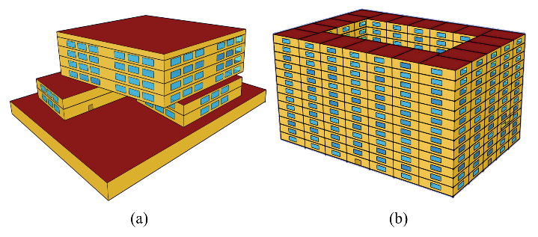
- Geometric models of the case-study buildings: (a) Building 1; (b) Building 2

Envelope Parameters:
To facilitate the computation of the thermodynamic prior feature ($Q_{e}$), essential thermal parameters were extracted from the design specifications. The specific heat transfer coefficients for the primary envelope components are summarized in Table I.
- Thermal Properties of the Case Study Buildings (W/(m²·K))
Building ID | Wall | Window | Roof | Floor | Ground | Door
Building 1 | 0.45 | 2 | 0.35 | 1.2 | 1.5 | 2
Building 2 | 0.4 | 2.2 | 0.35 | 1.25 | 1.6 | 2

Weather Data
Historical hourly weather data were sourced from the NASA POWER database to construct the weather data $m_{t}$, which includes outdoor dry-bulb temperature ($T_{out}$), wet-bulb temperature ($T_{wb}$), and solar irradiance ($I$). The dynamic characteristics of these meteorological variables are visualized in Fig. 4 and Fig. 5.
As illustrated in Fig. 4, the region undergoes severe cold periods, with outdoor temperatures frequently plummeting below -20°C accompanied by significant diurnal swings. Concurrently, Fig. 5 highlights the stochastic nature of solar irradiance, characterized by intense intermittency.
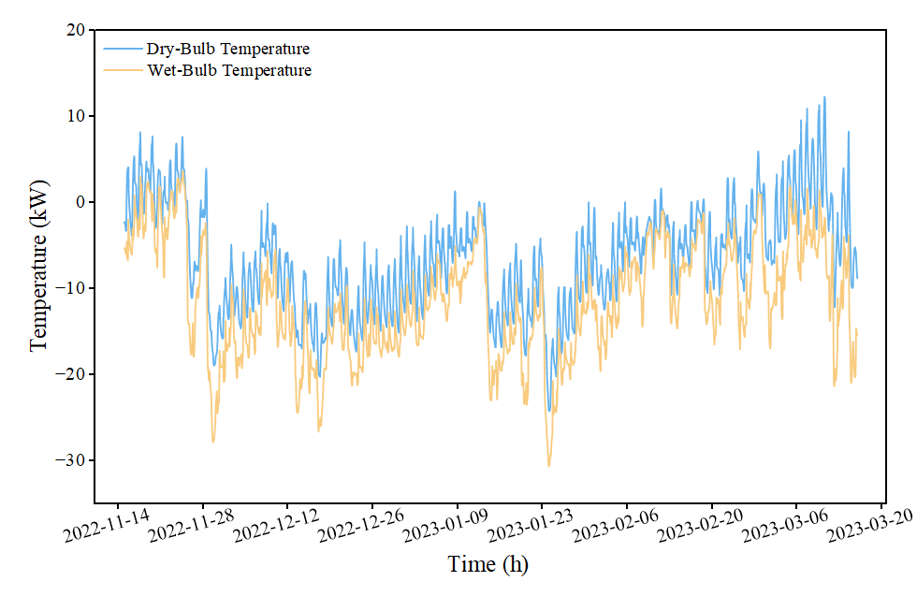
- Hourly profiles of temperature data
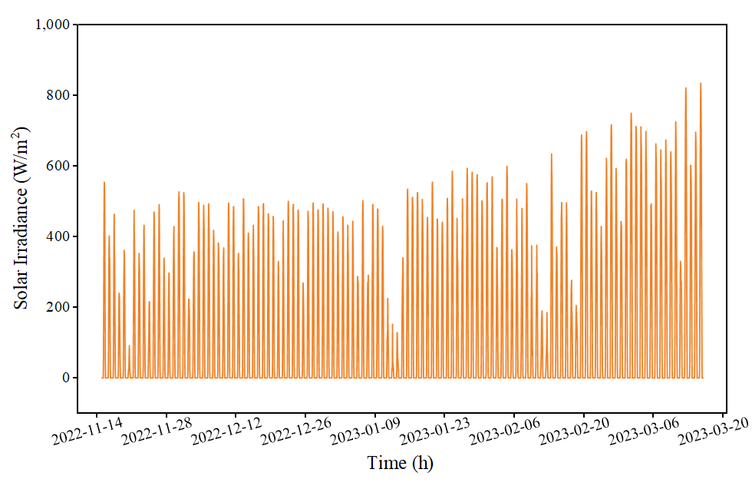
- Hourly solar irradiance profile

Training Settings
All models were implemented using the PyTorch deep learning framework and accelerated on an NVIDIA GPU. To ensure a fair comparison, identical hyperparameter configurations were maintained for both ThermoNet and the baseline LSTM. The training process utilized the Adam optimizer to minimize the MSE loss function. Furthermore, the dataset was split chronologically into training (80%) and testing (20%) sets to prevent data leakage.

Resuilts
To rigorously validate the effectiveness of the proposed framework, we conducted a comprehensive comparative analysis between ThermoNet and the baseline LSTM. The evaluation focuses on two key dimensions: overall predictive accuracy across the entire test set and dynamic responsiveness to large daily temperature variations.

Overall Performances
The quantitative performance metrics for both building types are summarized in Table II. The results demonstrate that ThermoNet consistently outperforms the LSTM, achieving lower error rates and substantial improvements in R².
- Performance Comparison on Different Buildings
Building ID | Model | RMSE (kW) | MAE (kW) | R²
Building 1 | ThermoNet | 87.72 | 70.33 | 0.89
 | LSTM | 177.87 | 154.86 | 0.57
Building 2 | ThermoNet | 178.33 | 141.02 | 0.86
 | LSTM | 269.14 | 225.20 | 0.68

Analysis of Building 1
Building 1 presents a difficult forecasting scenario due to high volatility driven by irregular commercial activities. As shown in Fig. 6, the LSTM provides a relatively poor fit with an R² of only 0.57. It fails to capture high-frequency fluctuations and tends to smooth out significant load variations. In contrast, ThermoNet improves this metric drastically to 0.89 and reduces the RMSE by 50.6%. By using the calculated envelope load $Q_{e}$ as a deterministic baseline, ThermoNet filters out the noise inherent in the commercial data. This allows the neural network to focus on learning residual behavioral patterns, resulting in superior robustness against non-stationary loads.
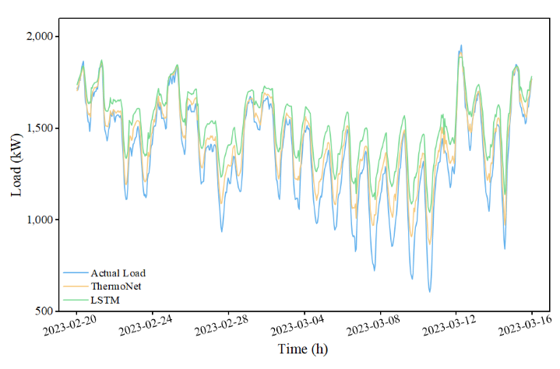
- Comparative load forecasting results on the test set for Building 1

Analysis of Building 2
The load profile of Building 2 exhibits distinct weekly periodicity, as illustrated in Fig. 7. While the LSTM captures the general trend, it frequently overestimates the base load during off-peak hours and struggles to match the precise amplitude of daily peaks. ThermoNet aligns much closer to the actual load, particularly during the sharp transitions between day and night operations. This improved alignment translates to a 33.7% reduction in RMSE and an increase in R² to 0.86. Here, the thermodynamic feature acts as a physical constraint, effectively correcting the baseline drift often observed in pure data-driven models.
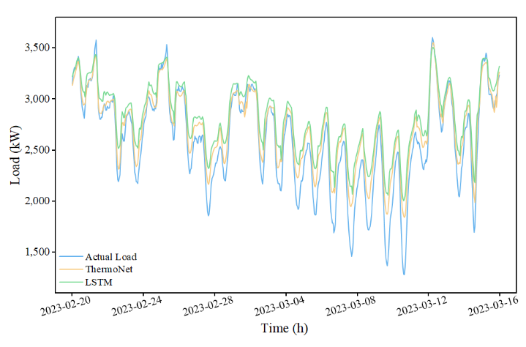
- Comparative load forecasting results on the test set for Building 2

Responsiveness to Large Daily Temperature Variations
Standard deep learning models often exhibit slow reaction times when the weather changes rapidly throughout the day. This prediction lag causes prediction errors, especially on days with large temperature swings. To evaluate the responsiveness of ThermoNet, we analyzed a 48-hour window from 13:00 on March 13 to 12:00 on March 15. This window captures a significant temperature fluctuation event on March 14, where the outdoor temperature rose rapidly from a morning low of -4.62°C at 06:00 to a peak of 8.23°C at 14:00, followed by a precipitous drop to -9.38°C by midnight.

Performance in Building 1
Fig. 8 illustrates the model comparison for Building 1. During the rapid temperature rise between 12:00 and 14:00, the actual heating demand dropped to a daily minimum of 842.5 kW. The LSTM failed to adapt quickly to this change and acted as if the building still required high heating, predicting a load of 1140.1 kW. This 35% overestimation indicates that the baseline model failed to capture the sudden drop in demand, which would lead to overheating and energy waste in a real system. In contrast, ThermoNet reacted immediately. Guided by the envelope load $Q_{e}$ as a direct input, the model instantly recognized the warming trend and lowered its prediction to 973.5 kW, reducing the absolute prediction error by approximately 56% compared to the baseline LSTM. This result confirms that integrating the physical feature enables the model to track rapid load changes with significantly reduced latency.
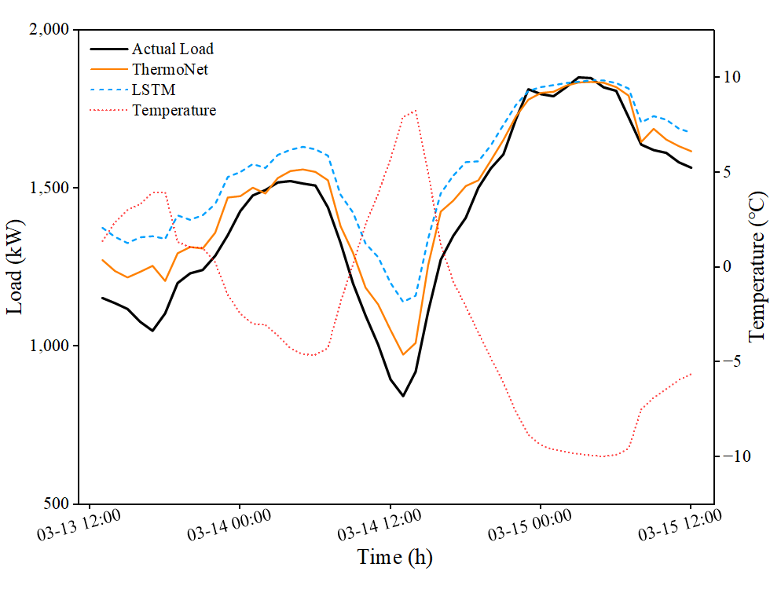
- Response analysis for Building 1

Performance in Building 2
A similar trend appears in the results for Building 2, as presented in Fig. 9. Throughout the warmer hours of the day, the LSTM consistently predicted higher loads than necessary and lagged behind the actual downward trend. ThermoNet, guided by the physical calculation, followed the steep drop in the actual load curve closely. By resolving this latency issue, ThermoNet ensures that the district heating system can reduce heat supply precisely when the outdoor temperature rises, thereby avoiding energy waste while maintaining indoor comfort.
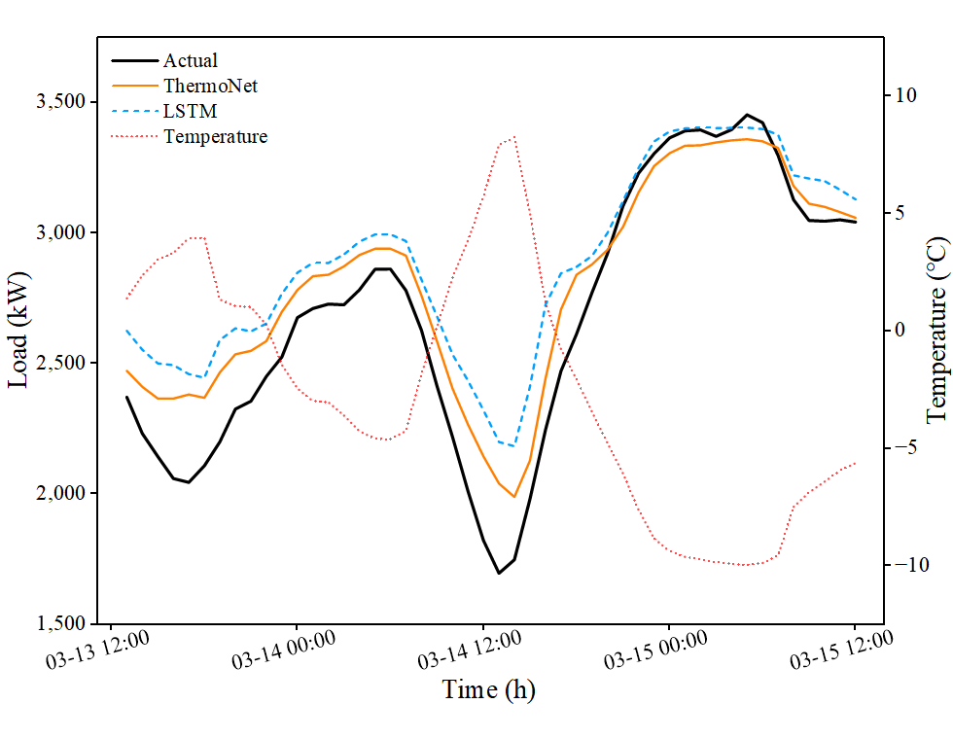
- Response analysis for Building 2

Conclusions
In this paper, a physics-informed deep learning framework, named ThermoNet, is proposed to address the intrinsic limitations of traditional data-driven models, such as poor generalization and prediction hysteresis during rapid weather changes. A simplified thermodynamic envelope load is calculated based on fundamental heat transfer principles and real-time meteorological data. This feature acts as a deterministic prior, effectively solving the problem that pure neural networks are agnostic to physical laws. Then, a hybrid LSTM architecture integrating this physical feature with historical load data is constructed to predict the future heating demand of district heating systems. Experimental results on two distinct building archetypes demonstrate that ThermoNet significantly outperforms the baseline LSTM. It reduces the RMSE by 50.6% and 33.7%, respectively, and effectively eliminates prediction latency during large diurnal temperature fluctuations. The results indicate that the proposed framework has strong robustness and is engineering applicable for the optimal control of smart thermal grids.

Acknowledgment
This work is supported by National Key R&D Program of China (No. 2024YFB4206500), National Natural Science Foundation of China (No. 51806190) and "Pioneer" and "Leading Goose" R&D Program of Zhejiang (No. 2025C02237).

References
[1] A. Shakeel, D. Chong, and J. Wang, “Load Forecasting of District Heating System Based on Improved Fb-Prophet Model,” Social Science Research Network, Rochester, NY: 4251873. Accessed: Dec. 19, 2025. [Online]. Available: https://papers.ssrn.com/sol3/papers.cfm?abstract_id=4251873
[2] H. Lund et al., “4th Generation District Heating (4GDH): Integrating smart thermal grids into future sustainable energy systems,” Energy, vol. 68, pp. 1–11, Apr. 2014, doi: 10.1016/j.energy.2014.02.089.
[3] F. Wernstedt, P. Davidsson, and C. Johansson, “Demand side management in district heating systems,” in Proceedings of the 6th international joint conference on Autonomous agents and multiagent systems, Honolulu Hawaii: ACM, May 2007, pp. 1–7. doi: 10.1145/1329125.1329454.
[4] A. Castellini, F. Bianchi, and A. Farinelli, “Predictive Model Generation for Load Forecasting in District Heating Networks,” IEEE Intelligent Systems, vol. 36, no. 4, pp. 86–95, July 2021, doi: 10.1109/MIS.2020.3005903.
[5] K. Amasyali and N. M. El-Gohary, “A review of data-driven building energy consumption prediction studies,” Renewable and Sustainable Energy Reviews, vol. 81, pp. 1192–1205, Jan. 2018, doi: 10.1016/j.rser.2017.04.095.
[6] M. S. Ahamed, H. Guo, and K. Tanino, “Modeling heating demands in a Chinese-style solar greenhouse using the transient building energy simulation model TRNSYS,” J. Build. Eng., vol. 29, p. 101114, May 2020, doi: 10.1016/j.jobe.2019.101114.
[7] X. Lin, J. Zhang, L. Du-Ikonen, and W. Zhong, “An infiltration load calculation model of large-space buildings based on the grand canonical ensemble theory,” Energy, vol. 275, p. 127331, July 2023, doi: 10.1016/j.energy.2023.127331.
[8] S. Rouchier, M. Rabouille, and P. Oberlé, “Calibration of simplified building energy models for parameter estimation and forecasting: Stochastic versus deterministic modelling,” Building and Environment, vol. 134, pp. 181–190, Apr. 2018, doi: 10.1016/j.buildenv.2018.02.043.
[9] W. Kong, Z. Y. Dong, Y. Jia, D. J. Hill, Y. Xu, and Y. Zhang, “Short-Term Residential Load Forecasting Based on LSTM Recurrent Neural Network,” IEEE Transactions on Smart Grid, vol. 10, no. 1, pp. 841–851, Jan. 2019, doi: 10.1109/TSG.2017.2753802.
[10] A. Karpatne et al., “Theory-Guided Data Science: A New Paradigm for Scientific Discovery from Data,” IEEE Transactions on Knowledge and Data Engineering, vol. 29, no. 10, pp. 2318–2331, Oct. 2017, doi: 10.1109/TKDE.2017.2720168.
[11] Y. Wang, C. Zhan, G. Li, D. Zhang, and X. Han, “Physics-guided LSTM model for heat load prediction of buildings,” Energy and Buildings, vol. 294, p. 113169, Sept. 2023, doi: 10.1016/j.enbuild.2023.113169.
[12] H. Kazmi, C. Fu, and C. Miller, “Ten questions concerning data-driven modelling and forecasting of operational energy demand at building and urban scale,” Building and Environment, vol. 239, p. 110407, July 2023, doi: 10.1016/j.buildenv.2023.110407.
[13] Z. Ma, G. Jiang, Y. Hu, and J. Chen, “A review of physics-informed machine learning for building energy modeling,” Appl. Energy, vol. 381, p. 125169, Mar. 2025, doi: 10.1016/j.apenergy.2024.125169.
[14] Z. Li, N. Zhang, J. Zhang, X. Lin, and W. Zhong, “Load Forecasting of Large-space Stadium Based on Surrogate Modeling,” in 2022 International Conference on High Performance Big Data and Intelligent Systems (HDIS), Dec. 2022, pp. 299–303. doi: 10.1109/HDIS56859.2022.9991695.

